This document must be read in conjunction with your Student Unit Guide as it provides instructions regarding this assessment task including the required evidence.
ICTWEB411&&452 Student Unit Guide v1.0
Student Details
Student Name | Click or tap here to enter text. |  | Student No. |  | Click or tap here to enter text.
Student contact email | Click or tap here to enter text.
Student phone contact | Click or tap here to enter text.
Submission Record
VET Lecturer Name | Click or tap here to enter text.
Date student submitted | Click or tap to enter a date. | Date assessed |  | Click or tap to enter a date.

Task 1
Task Title | Create a web form incorporating HTML5 data validation according to requirements.
Create a web form exactly as in the diagram below, incorporating HTML5 data validation and correct field types.
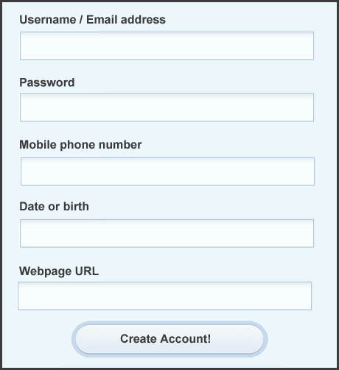
Form specifics:
- Must have a background colour of #ecf7fc.
- Must have labels in Arial bold, 11pt, #3b3b3b.
- Form inputs must look the same as in the graphic.
- There must be a border of 3px #3b3b3b around the form, with padding.
- The button must look exactly how it does in the graphic - same text styling as the labels.
- The form must include accessibility syntax.
- The page must validate with no errors (other than warnings about HTML5).
- The form must be on a mark-up document called form.htm
- The styles must be contained on a stylesheet called styles.css and this is to be located in a folder called ‘css’.
- There are to be NO images used in this task.
- HTML5 Validation for the Username / Email address and Password fields must check if they contain data and if it’s a valid email address (Required).
- Correct HTML5 form fields for all the fields.
- All elements must be contained in a folder called ‘task1’.

Organisational requirements:
- Accessibility (must pass W3C validation without errors);
- Compatibility (must render in different browsers)

Task 2
Task Title | Create a responsive web page using the correct HTML5 mark-up and according to requirements.
Create a page with the following areas (page structure) using the correct HTML5 mark-up. This page will be used as a template for a real organisation. There are a couple of organisational requirements for the page:
  - accessibility (must pass W3C validation without errors);
  - compatibility (must render in different browsers and devices).

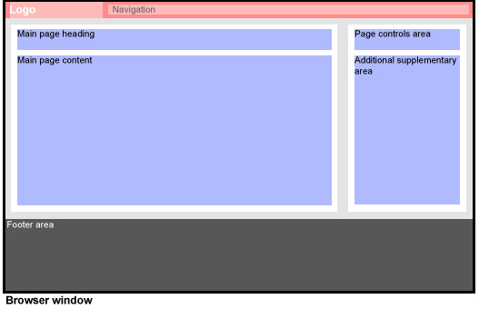
Page specifics:
The page must be responsive to the width of the window.
The page must be compatible with different browsers and devices.
The page must have an easy to use navigation (accessible).
The red area must be greater than 125px high and less than 300px.
You must include a navigation structure using a list to: Services, About Us, Contact, Home.
The logo area must align with the white area of the Main page areas.
The Main Page (left) area must be responsive with the width of the window.
The background of the middle section must be grey (like in the image).
The main body areas, both left and right must have a white background.
The purple areas are invisible containers for where the text will appear.
You must use semantic mark-up for your headings.
The white area on the right must remain a fixed width and always align right.
The footer area must be responsive to the browser width. The area must be dark grey and 300px high.
You must use descriptive semantic mark-up syntax for all areas of the page including the use of structural HTML elements.
The page must include accessibility syntax and must validate via the w3c validator.
You will have 1 checklist document and 1 mark-up page called layout.htm, an image (if you want) in a folder called ‘images’ and a style sheet called styles.css in a folder called ‘css’.
All elements of this task are to be contained in a folder called ‘task2’.
Refer to the checklist below. Check each requirement against the items and respond to all questions. Include additional comments and explanations where necessary. The completed checklist must be submitted as a separate document named assessment_2_task_2_checklist.docx
Checklist for Assessment 2 Task 2
Name:
Requirements | Comment/Explanation | Addressed? (Yes/No)
The page is responsive to the width of the window.
The page is compatible with different browsers and devices.
The red area is greater than 125px high and less than 300px.
Navigation structure contains Services, About Us, Contact and Home.
The logo area aligns with the white area of the Main page areas.
The Main Page (left) area is responsive with the width of the window.
The background of the middle section is grey.
The main body areas, both left and right, have a white background.
The semantic mark-up is used throughout the whole document.
The white area on the right remains a fixed width and always aligns right.
The footer area is responsive to the browser width. The area is dark grey and 300px high
The page includes accessibility syntax and validates via the w3c validator
User Acceptance (Name) | Signature | Date

Task 3
Task Title | Produce documentation.
Write up documentation in a business format for a junior developer to place content to the template created in Task2.
The documentation must contain a step-by-step instruction sheet on how to add/modify or remove articles from the “main page content” area, change “main page heading”, and update the logo.
This step by step instruction sheet is to include information like logo picture resolution, file location and specifics on how to modify your code to incorporate the changes.
This document is to be included in a folder called ‘task 3’.
The documentation must be submitted as a separate document named ssessment_2_task_3_documentation.docx
Task 4
Task Title | Obtain signoff
Following the submission guidelines illustrated below, submit the completed Task 1, Task 2 and Task 3 for marking and sign off.
An electronic zipped folder containing all documents associated with this assessment task.
Task 1 | 1 mark-up document called form.htm, a stylesheet called ‘styles.css’ in a folder called ‘css’.
Task 2 | 1 checklist document.  1 mark-up page called layout.htm, an image (if you want) in a folder called ‘images’ and a style sheet called styles.css in a folder called ‘css’.
Task 3 | 1 document (instruction for updating information in the template created in Task2)
Submitted to your lecturer@cdu.edu.au
The submission must be from CDU student email account.
The subject must include student number, course code, unit code, assessment title and the assessor name, for example: S123456, ICTWEB452, Assessment 2, assessor name

Feedback and overall assessment outcome of the task
Result Attempt 1 | ☐ Satisfactory ☐ Unsatisfactory
Enter student feedback here for attempt

VET Lecturer Name
VET Lecturer Signature |  | Date | Click for date
Result Attempt 2 | ☐ Satisfactory ☐ Unsatisfactory
Enter student feedback here for attempt

VET Lecturer Name
VET Lecturer Signature |  | Date | Click for date

